AIR CONDITIONER

WITH

REMOTE CONTROL

*Minor project of*

*Course Title: Skilling (LabVIEW)*

*Course code: 17TS401*

*Submitted by*

*I. GOVINDA RAO(170040295)*

*J. PAVAN SAI (170040307)*

*J.V.N.D.S.R.Prasad (170040320)*

*Submitted to*

*Ms. Mona Mudaliar*

*(Asst. professor)*Department of ECE



**BONAFIDE CERTIFICATE**

This is to certify that the projectbased laboratory report entitled “Air conditioner with remote control**”** submitted by I Govinda rao, J Pavan sai, J. Prasad, bearing registration numbers 170040295, 170040307, 170040320, in partial fulfillment of project based lab in skilling for II/IV **Bachelor of Technology in Electronics and Communication Engineering** is a bonafide record of the work carried out under our guidance and supervision at KL University during the academic year 2018-19

**Signature of HOD Signature of Project Guide**

**ACKNOWLEDGEMENT**

It is great pleasure for me to express my gratitude to our honorable President

Sri. KoneruSatyanarayana, for giving us the opportunity and platform with

facilities for accomplishing the project based laboratory report.

We express our sincere gratitude to our Coordinator, Mr. Khanal Madhav

Prasad for his leadership and constant motivation provided for the successful

completion of our academic semester. We record it as our privilege to deeply

thank, for providing us the efficient faculty and facilities to make our ideas into

reality.

We express our sincere thanks to our project supervisor Ms. Mona Mudaliar

for her novel association of ideas, encouragement, appreciation and intellectual

zeal which motivated us to venture this project successfully.

Finally, we are pleased to acknowledge the indebtedness to all those who

devoted themselves directly or indirectly to make this project report a success.

I.D NUMBER NAME

170040295 I Govinda rao

170040307 J Pavan sai

170040320 J.V.D.S.R.Prasad

**ABSTRACT**

LabVIEW is a development environment for creating graphical programs called virtualinstruments(VI) that simulate actual laboratory instruments. A VI consists of two parts: a frontpanel and a backpanel. The front panel allows the user to interact with the VI by displaying output and allowing the user to supply the program with input. The back panel consists of the code used by the VI to obtain input from the front panel, operate on the input, and display the results.

The front panel is built using controls and indicators. Controls are inputs that allow a user to supply information to the VI. Indicators are outputs that display the results based on the inputs given to the VI.

The calculator can perform a number of simple mathematical operations and utilities the Producer/Consumer (Events) design pattern. When running the program, hover over certain buttons to display a tip strip as to their operation. When analyzing the block diagram, display Context Help (Ctrl-H) and hover over SubVIs to get a description of functionality.

REQUIREMENTS

Labview 2018(or any compatible version)

**INDEX**

|  |  |  |  |  |  |  |  |  |  |  |  |  |  |  |  |  |  |  |  |  |  |  |  |  |  |  |  |  |  |  |  |  |
| --- | --- | --- | --- | --- | --- | --- | --- | --- | --- | --- | --- | --- | --- | --- | --- | --- | --- | --- | --- | --- | --- | --- | --- | --- | --- | --- | --- | --- | --- | --- | --- | --- |
| |  |  |  | | --- | --- | --- | | **S.NO** | **TITLE** | **PAGE NO** | | 1. | Introduction | 6-8 | | 2. | List of Figures | 9 | | 3. | List of Tables | 10 | | 4. | Technical description of the project | 11 | | 5. | Block Diagram | 12-13 | | 6. | Front Panel | 14-15 | | 7. | Result | 16 | | 8. | Future Scope | 16-19 | | 9. | Conclusion&References | 20 | |  |  |
|  |  |  |
|  |  |  | |
|  |  |  | |
|  |  |  | |

**INTRODUCTION**

A system for controlling the temperature in a building or vehicle, typically to maintain a cool atmosphere in warm conditionsand utilities the Producer/Consumer (Events) design pattern. When running the program, however over certain buttons to display a tip strip as to their operation. When analyzing the block diagram, display Context Help (Ctrl-H) and however over SubVIs to get a description of functionality.

We have build the circuit user friendly ,user can control the temperature using the remote by pressing ok buttons ( are named as swing and on/off).this virtual air conditioner is used to cool that particular area.

**LabVIEW**:-

Lab VIEW (short for Laboratory Virtual Instrumentation Engineering Workbench) is a platform and development environment for a visual programming language from National Instruments. Originally released for the Apple Macintosh in 1986, Lab VIEW is commonly used for data acquisition, instrument control, and industrial automation on a variety of platforms including Microsoft Windows, various flavors of UNIX, Linux, and Mac OS.The programming language used in Lab VIEW, is a dataflow language. Execution is determined by the structure of a graphical block diagram.

Lab VIEW ties the creation of user interfaces (called front panels) into the development cycle. Lab VIEW programs/subroutines are called virtual instruments (VIs). Each VI has three components:-

1. Block diagram

2. Connector pane

3. Front panel

One benefit of labview over other development environments is the extensive support for accessing instrumentation hardware. Drivers and abstraction layers for many different types of instruments and buses are included or are available for inclusion. These present themselves as graphical nodes. The abstraction layers offer standard software interfaces to communicate with hardware devices. The provided driver interfaces save program development time. The sales pitch of National Instruments is, therefore, that even people with limited coding experience can write 5 programs and deploy test solutions in a reduced time frame when compared to more conventional or competing systems. A new hardware driver topology (daqmxbase), which consists mainly of Gcoded components with only a few register calls through NI Measurement Hardware DDK (Driver Development Kit) functions, provides platform independent hardware access to numerous data acquisition and instrumentation devices. The daqmxbase driver is available for labview on Windows, macosx and Linux platforms.

**LIST OF FIGURES**

1.SELECT



2.FAN

3.OK BUTTON



4.RING



5.BOOLEAN



6.TIMER



7.AND GATE



**LIST OF TABLES**

1.WHILE LOOP



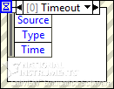 2.EVENT STRUCTURE

3.CASE STRUCTURE

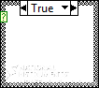

**TECHNICAL DESCRIPTION OF THE PROJECT**

1. The property node to [getorsetpropertiesandmethods](lvconcepts.chm::/Manip_App_VI_Settings.html#Property_Nodes) on local or remote [application instances](lvconcepts.chm::/Application_Instances.html), VIs, and objects. The Property Node to class. The Property Node automatically adapts to the class of the object that you **reference**.
2. This programme is made using a simple while loop and event structure.
3. Here we will give room temperature using remote and desired temperature in numeric controller and display using event structure and leds.
4. Programme will start when we press on/off button and swings if we press swing button.
5. Room temperature is the number between (17-30) and desired temperature is given by us using temperature control in remote, that temperature is displayed in remote and numeric indicator.
6. Task of Boolean becomes true if power is on
7. A while loop is taken, thermometer is immersed in it and conditions like true or false , and some ok buttons and select options are given and some controls are given to control ac.

**BLOCK DIAGRAM**

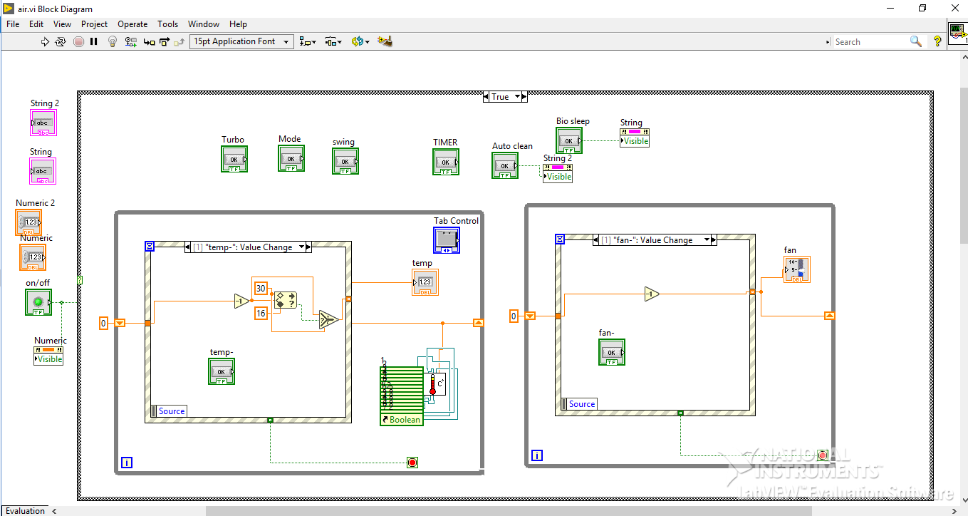

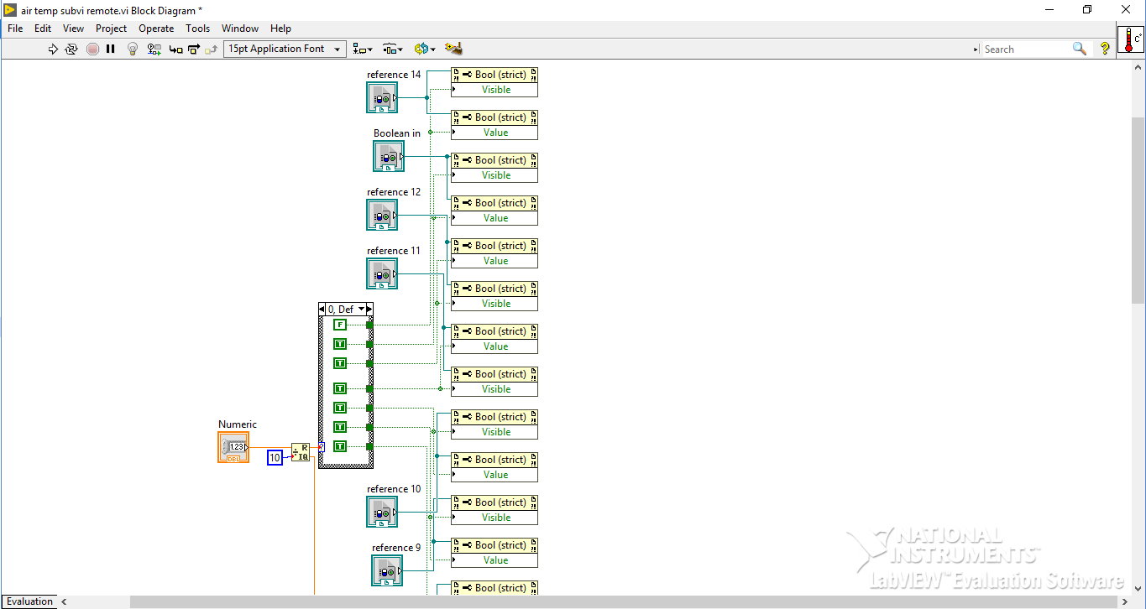

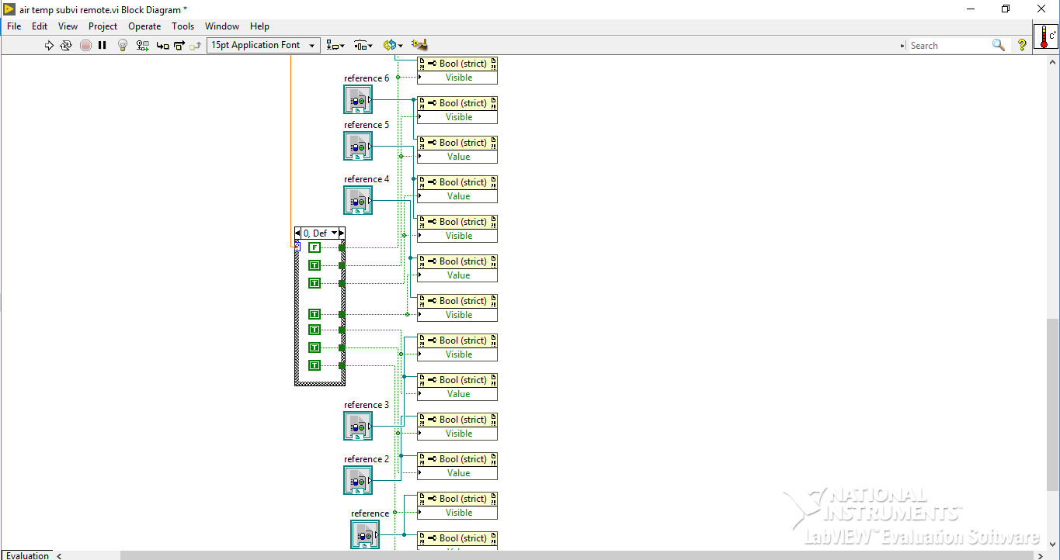

**FRONT PANEL**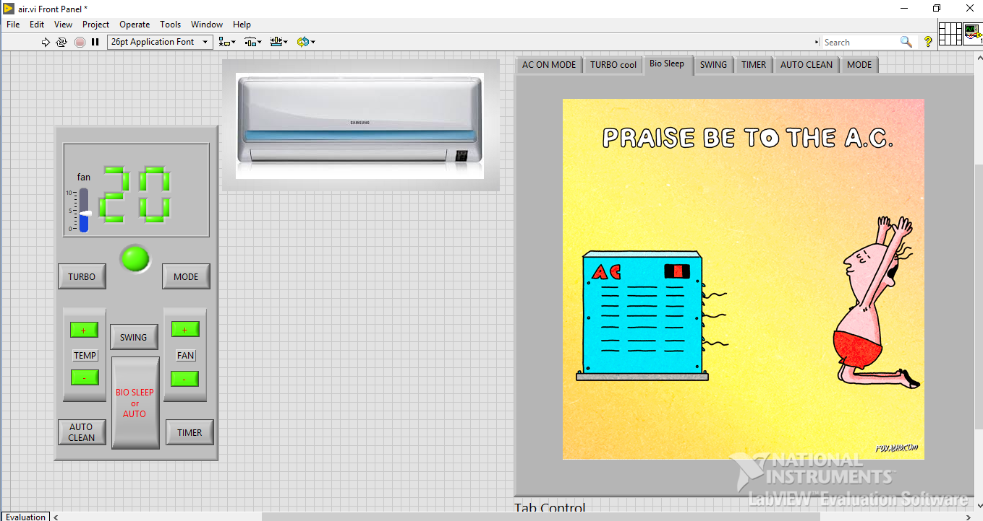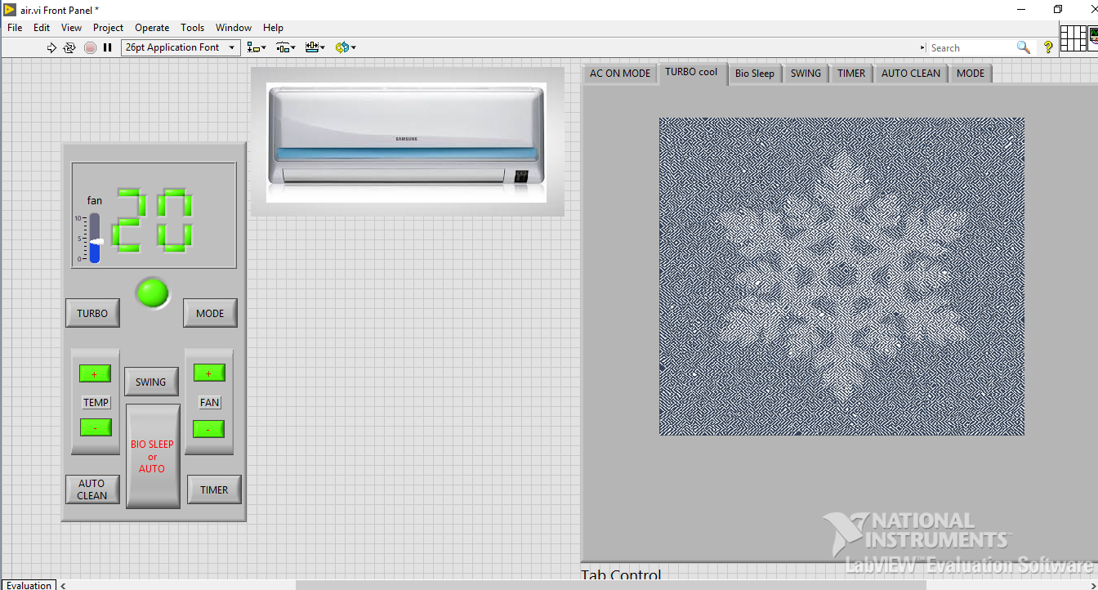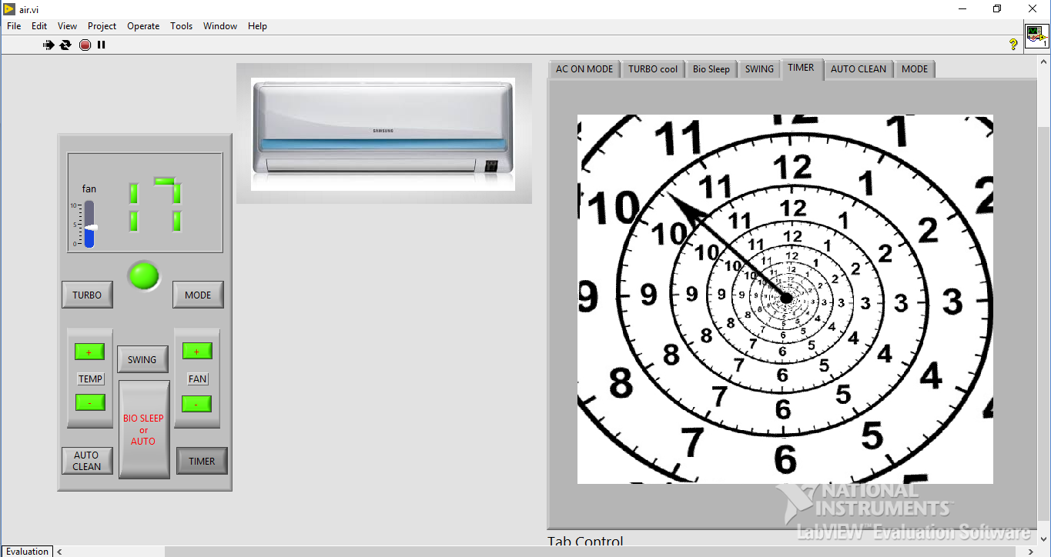

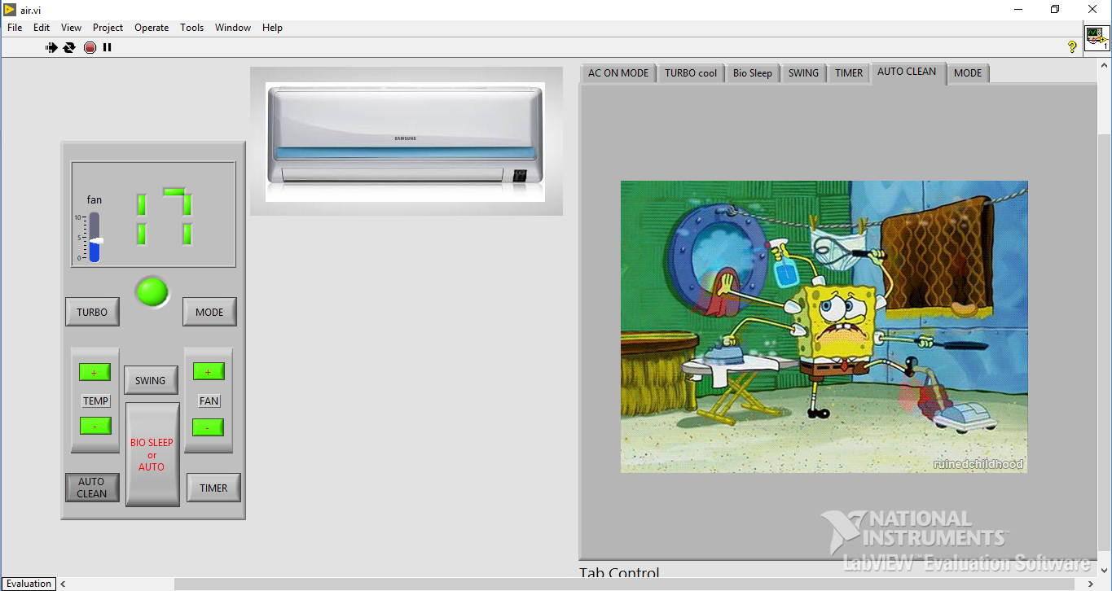

**RESULT :**

**Here we can control the AC using remote ,it displays the temperature and whether the AC is on/off. And can the display the working using gifs.**

**Future Scope:**

## **Automatic Climate Control (Automatic A/C) in Cars:**

The Automatic Climate Control system is the most advanced of all the [air conditioning](https://carbiketech.com/car-air-conditioner/)systems in cars. It effectively controls the cabin temperature and humidity levels. In Climate Control, you can set the cabin temperature of your choice. However, the system controls it regardless of the outside air temperature and humidity. Some advanced systems offer Dual-zone climate control with automaticre-circulationmode. 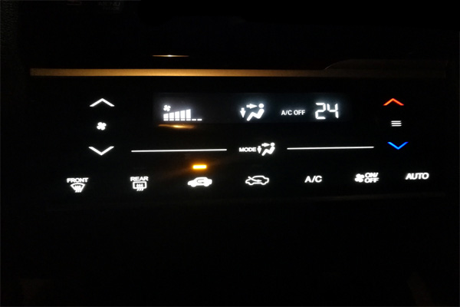

Automatic AC Control Panel

The automatic climate control system provides an individual feel-good climate for the occupants. It automatically controls the temperature, air-flow and air distribution inside the cabin. The climate control system also controls the fan speed and air circulation.

In some cases, the automatic climate control system provides electronic regulation of the air temperature, air flow rate, and air distribution. Some systems provide the

defroster nozzles for the windscreen and side windows to eliminate the fogging effect. Nowadays, budget cars also offer an Automatic [Air-Conditioner](https://carbiketech.com/car-air-conditioner/)(a step-down version of Automatic Climate Control) with touch screen panel for the ease of use.

AC air vent (Image courtesy: Bentley)

### **Features of Automatic Climate Control System:**

The automatic climate control system also measures the quality of the cabin air through various sensors. Some provide a separate climate control [ECM](https://carbiketech.com/engine-management-system-ems/) to control various sensors/actuators such as cabin air quality sensor and humidity sensor. The driver and front passenger can control the temperature separately for themselves. You can also precisely adjust the temperature levels, direction and intensity of the airflow through a touch-screen.

The Climate Control system can also maintain the temperature depending on the sunlight and the quality of the intake air through key-coded settings. Manufacturers use custom acronyms to brand their automatic climate control systems in cars. For e.g. [Mercedes-Benz](https://www.mbusa.com/mercedes/index) uses the term THERMOTRONIC for the Automatic Climate Control systems fitted in its cars.

Some manufacturers take the climate control to a new level. The driver and front passenger can independently set the temperatures of their choice for their respective areas. The rear passengers can also get better air quality with rear ventilation and re-circulation option.

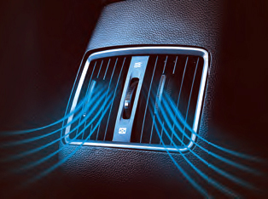Rear AC Vent (Image courtesy: Hyundai)

Mercedes-Benz provides a separate control unit with a display for the rear a/c. It also comprises of additional air outlets in the [B-pillar](https://carbiketech.com/vehicle-body-nomenclature-car-pillar/), air vents in the center console and a booster blower for the purpose. This ensures that the ideal temperature is maintained at the rear. Some manufacturers also provide 'roof a/c' or blowers in the roof in some bigger models to achieve the desired effect.

### **Automatic Climate Control in Luxury Cars:**Some ultra-luxury cars offer the state-of-the-art 4-zone air-conditioning. It includes an additional rear cabin air-conditioning unit with controls at the front and rear for fan speed and temperature. In some cars such as the [Bentley](https://www.bentleymotors.com/en/models/mulsanne/mulsanne.html) Mulsanne, you can control the rear air conditioner by the folding rear center-armrest console.Rear Climate Control in Luxury cars (Bentley)

Furthermore, some manufacturers, nowadays, provide an air-conditioned or cooled glove-box as a convenience option. So, it is getting popular among the budget car buyers. It keeps the water bottles/beverage cans cool. The cooled glove-box uses the cool air generated by the car’s air conditioner to cool the stuff put in it. So, you can keep water-bottles and the cans of aerated drinks to cool them.

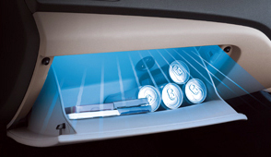Cooled Glove Box Rear AC Vent (Image courtesy: Hyundai)

### **Tips for using the Automatic Climate Control effectively:**

1. Always keep the front grill clear of any obstructions for the proper functioning of the air conditioner.
2. Always keep the windows rolled up to maximize the efficiency of the A/c.
3. Keep the air conditioner in the recirculating mode when in use
4. Use the ‘Fresh-Air’ mode only when it is necessary.
5. To improve [fuel efficiency](https://carbiketech.com/fuel-economy-car-mileage-bike-average/), use the air-conditioner only when it is necessary.

**CONCLUSION:**

**From this project we can conclude that we are able to build the AC using the Lab View.**

**REFERENCES**

<https://forums.ni.com/t5/LabVIEW/Air-Conditioning-Simulation/td-p/2421584>